Design of a Direct-Sampling Receiver Chain
for a Frequency-Hopping CPFSK System
Specification · RF front end · digital down-converter · decode kernel · fixed-point core · HDL · ModelSim verification
RFSoC direct-RF sampling · signal centered at 2 GHz

66 / 66 frames decoded, CRC-valid — all 11 captured waveforms (3 clean + 8 barrage-jammed / ±5%-timing)
Worst-case acquisition latency 143.5 ns (budget 400 ns) · Live ModelSim RTL: bit-exact vs MATLAB

1. Transmitted signal
The system transmits a frequency-hopping CPFSK burst. This section specifies the transmitted waveform, its frame, and the operating conditions the signal is subject to. The receiver that recovers it — its requirements, chain, and implementation — is specified in Section 2 onward.

1.1 Waveform and frame
Parameter | Specification
Modulation | Continuous-phase FSK (CPFSK), binary (1 bit/symbol)
Hopping | Frequency-hopping, 6 channels
Hop-set center | 2.0 GHz
Channel spacing | 18 MHz
Occupied RF band | 1.58–2.20 GHz
Tone separation | 8 MHz (±4 MHz about each channel center)
Symbol / bit rate | 8 Msym/s (8 Mbit/s)
Burst structure | 6 dwells per transmission; 96 symbols per dwell
Frame (96 bits) | 8-bit 1010 preamble · 5-bit SFD (=11101) · 3-bit seq · 8-byte payload · 16-bit CRC-16
The waveform is a 6-channel FH-CPFSK burst. Each transmission is a sequence of six dwells; within a dwell the transmitter sends one 96-symbol framed packet: an 8-bit periodic-1010 preamble, a 5-bit sync/SFD marker, a 3-bit sequence number, an 8-byte payload, and a CRC-16. The six hop channels are spaced 18 MHz apart about a 2.0 GHz center and occupy the 1.58–2.20 GHz band.
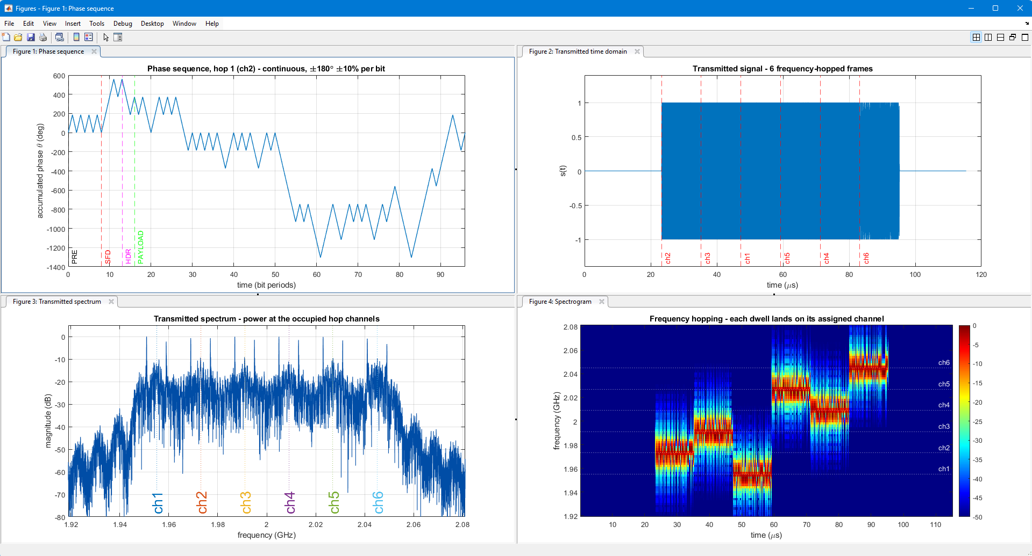
Figure 1 — Example transmitter output: (top-left) continuous accumulated phase for one hop with the PRE/SFD/HDR/PAYLOAD fields; (top-right) the six frequency-hopped dwells in the time domain; (bottom-left) transmitted spectrum over the six occupied hop channels; (bottom-right) spectrogram — each dwell lands on its assigned channel.

1.2 Operating conditions
The transmitted signal is subject to the following impairments and transmitter tolerances that define the difficulty of recovering it:
- Barrage jamming — a wideband jammer is present across the band, raising the noise floor of the matched-filter channel-energy estimate throughout every dwell.
- ±5 % timing — the symbol period varies by up to ±5 % from dwell to dwell, so the receiver cannot assume a fixed nominal period.
- Frequency-deviation error — the per-bit FSK deviation varies by up to ±10 % from its nominal ±4 MHz (±Rb/2), so the tone spacing is not exact.
- Phase tolerance — the continuous-phase transition is ±180° per bit with a ±10 % per-bit tolerance (see the transmitter phase plot, Figure 1).

2. Receiver design and implementation
The receiver chain recovers the frames of Section 1 under those operating conditions. Its requirements and the chosen chain are specified first, then the block diagram, the architecture, the RF front end, and the decode kernel.

2.1 Requirements
Requirement | Specification
Decode | Every frame CRC-valid under both impairments simultaneously
Latency budget | ≤ 400 ns, from LNA input to first demodulated bit
Implementation | Fixed-point, HDL-Coder-synthesizable RTL, verified against the reference

2.2 Front end, converter, and digital chain
Parameter | Specification
RF front end | 8-stage cascade of real measured-S-parameter parts (≈26 dB @ 2 GHz, 2.57 ns group delay)
Converter | 14-bit RFSoC Gen3 RF-ADC, direct RF sampling at 5 GSa/s (first Nyquist, ≤2.5 GHz)
Digital down-conversion | Complex mix to baseband, 55 MHz low-pass, decimate to the working rate
Working baseband rate | 128 MSa/s (16 samples/symbol)
What the design achieves:
- Decode: every frame of every waveform decodes CRC-valid — 3 clean and 8 jammed files, 6 frames each = 66/66.
- Synthesizable: the fixed-point core is bit-exact against the floating-point reference and passes real ModelSim simulation of the generated Verilog.
- Latency: worst-case end-to-end acquisition (LNA input to first demodulated bit) is 143.5 ns against the 400 ns budget.
- Practical: decimating to complex baseband early keeps the RTL small enough to synthesise and simulate on ModelSim Starter Edition.

2.3 Receiver-chain block diagram
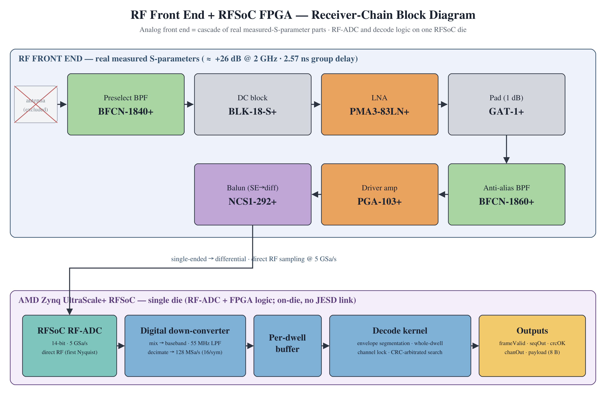
Figure 2 — RF front end and RFSoC FPGA logic — the seven real measured-S-parameter parts feed a 5 GSa/s RF-ADC; the on-die FPGA runs the DDC, per-dwell buffer, and decode kernel to produce the frame outputs.

2.4 Architecture overview
The receiver buffers one dwell at a time, measures that dwell’s symbol period directly from its envelope, locks the hop channel over the whole dwell, and then lets the CRC arbitrate a short phase-offset search for the frame start. Working on a buffered whole dwell (a two-pass approach) is what makes the chain robust to the barrage jammer and the ±5 % timing variation.
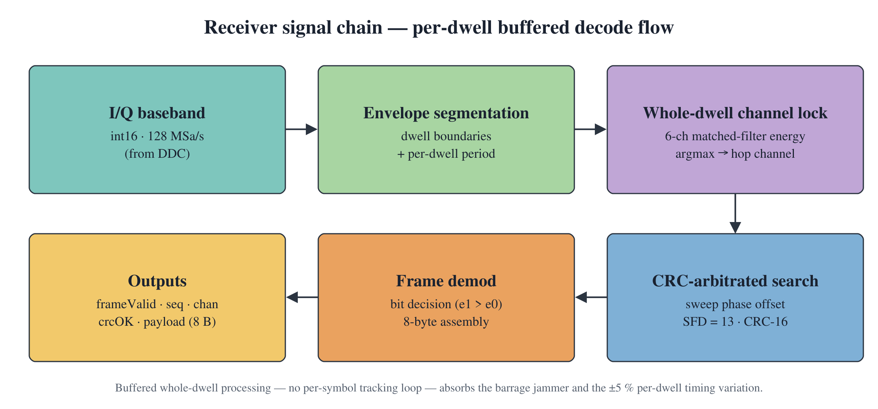
Figure 3 — Receiver signal chain: RF front end and DDC feed a per-dwell buffer; the decode kernel does channel-lock, period measurement, and a CRC-arbitrated offset search.

2.5 RF front end, sampling, and digital down-converter
The analog front end (rf_frontend.m) is not an idealized model: it is built from the measured S-parameters (Touchstone files) of real, catalogue commercial parts. Eight stages are cascaded in signal-flow order — a BFCN-1840+ preselect band-pass, a BLK-18-S+ DC block, a PMA3-83LN+ ultra-low-noise LNA, a GAT-1+ pad, a BFCN-1860+ anti-alias band-pass, a PGA-103+ driver amplifier, an NCS1-292+ balun (single-ended → differential), and an ADC-input DC block. Each part’s forward response S21(f) is read from its file and applied to the direct-sampled stream; the balun 3-port is converted to its mixed-mode forward response (S21 − S31)/√2. The net in-band gain is ≈26 dB at 2 GHz and the group delay used in the latency budget (2.57 ns) is read from the measured phase, not assumed.
Sampling rate. The signal occupies 1.58–2.20 GHz, so first-Nyquist direct sampling needs only ≥4.4 GSa/s. The target converter is a 14-bit RFSoC Gen3 RF-ADC running at 5 GSa/s (Nyquist 2.5 GHz), which covers the band with margin — no downconversion mixer is required ahead of it. The reference model and the captured waveforms in this package are generated at an oversampled 8.192 GSa/s instead; that rate is chosen only because it is an exact multiple of the working baseband (8.192 GSa/s = 64 × 128 MHz), so the DDC decimates by a clean D = 64. On the 5 GSa/s hardware the DDC uses the decimation factor that lands on the same 128 MSa/s baseband (≈39×, i.e. 4.992 GSa/s = 39 × 128 MHz); everything downstream operates in that fixed 128 MSa/s baseband and is unchanged. In short, 8.192 GSa/s is a modeling/capture rate, while 5 GSa/s is the physical converter rate.
The digital down-converter (frontend_ddc.m) mixes the 2 GHz-centred band to complex baseband, low-pass filters at 55 MHz, and decimates to 128 MSa/s (16 samples/symbol). Decimating first is what makes the RTL synthesisable: it cuts the per-dwell sample count so the buffer fits on-chip.
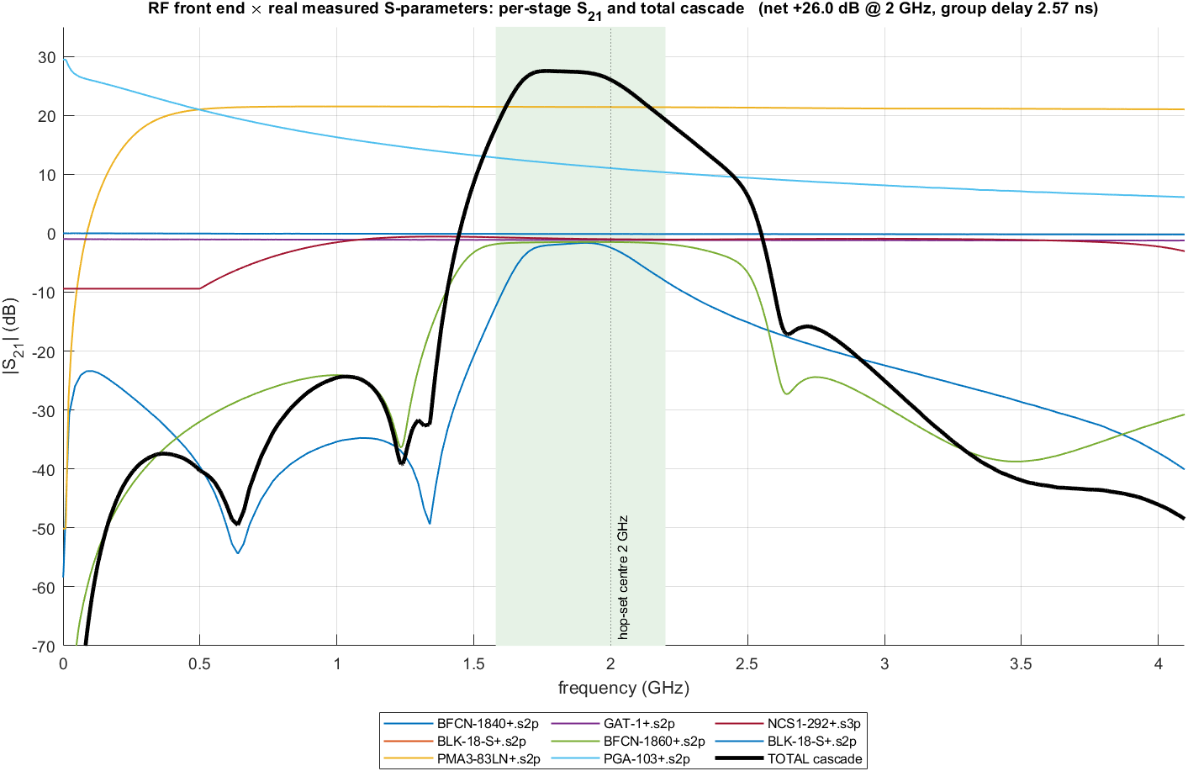
Figure 4 — Real measured RF front end: each component’s S21 (from its Touchstone file) and the total cascaded response. The BFCN-1840+/BFCN-1860+ pair selects the 1.58–2.20 GHz band (shaded) at ≈+26 dB, with deep out-of-band rejection.
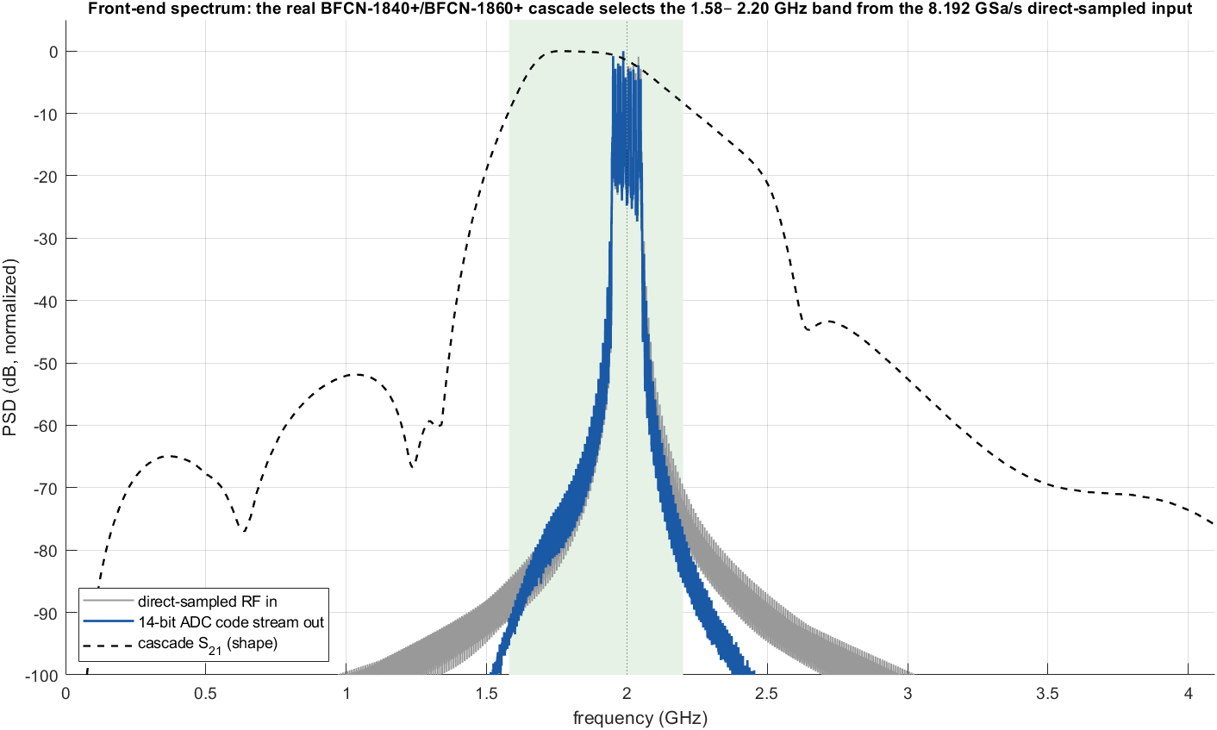
Figure 5 — Front-end spectrum: the measured cascade selects the signal band from the direct-sampled input; the ADC code-stream spectrum (blue) follows the cascade S21 shape (dashed).

2.6 The decode kernel (per-dwell buffered search)
- Segmentation: the active region / dwell boundaries are the envelope minima; the per-dwell period is per0 = (s1 − s0)/96. Measuring the period per dwell absorbs the full ±5 % timing spread with a single value.
- Channel lock: the sum over the dwell of the two tone correlations’ |Σ|², argmax over the 6 channels. A whole-dwell decision holds up under the barrage jammer.
- CRC-arbitrated offset search: the preamble is periodic 1010, so only the CRC-16 and SFD disambiguate the true frame start. The receiver sweeps a small phase-offset grid and stops on the first candidate with crcOK and SFD == 13.
The per-dwell diagnostics below (one barrage-jammed waveform, tx_20260808_111143) are shown as separate plots — channel lock, timing period, early-late discriminant, frame sync, and decode — each an independent view of the same record.
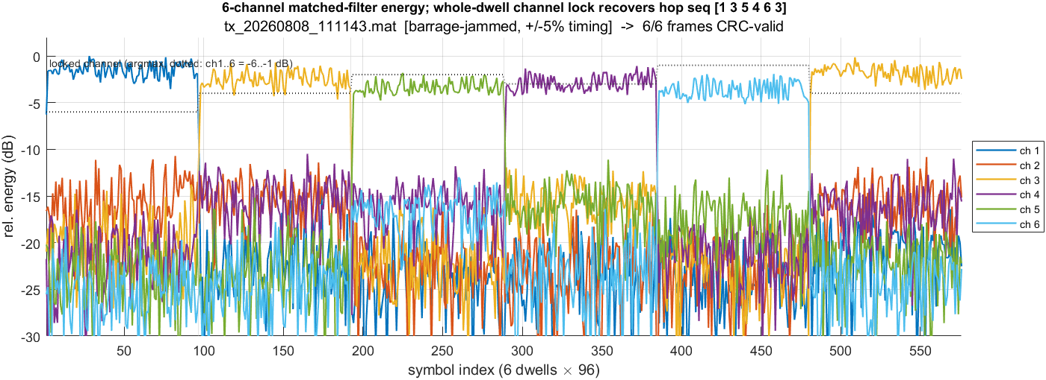
Figure 6 — Per-dwell channel lock: 6-channel matched-filter energy; the whole-dwell argmax recovers the hop sequence under the barrage jammer.
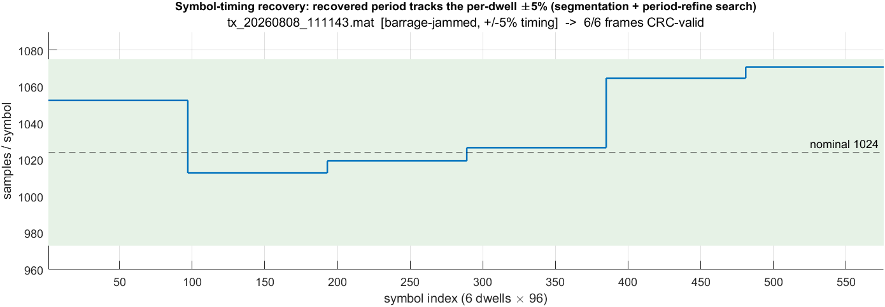
Figure 7 — Symbol-timing recovery: the recovered per-dwell period tracks the ±5 % drift (envelope segmentation + period-refine search).
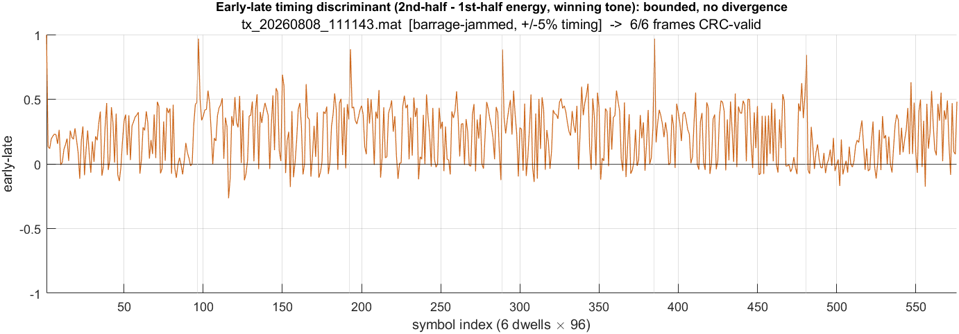
Figure 8 — Early-late timing discriminant (2nd-half − 1st-half energy on the winning tone): bounded, with no divergence.
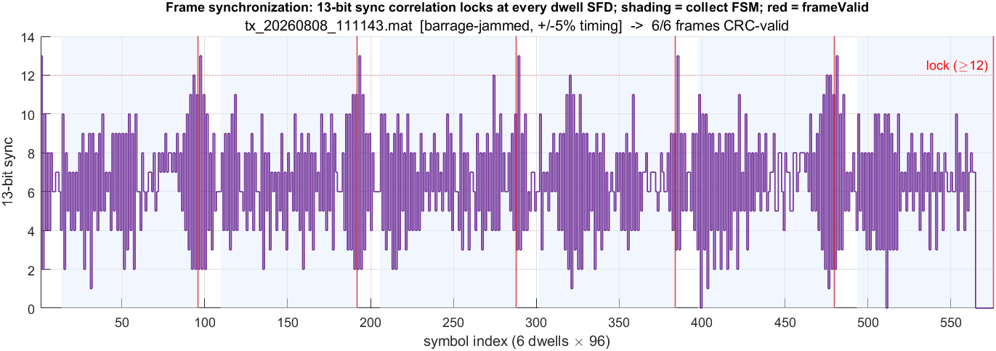
Figure 9 — Frame synchronization: the 13-bit sync correlation locks at every dwell SFD (shading = collect FSM; red = frameValid).
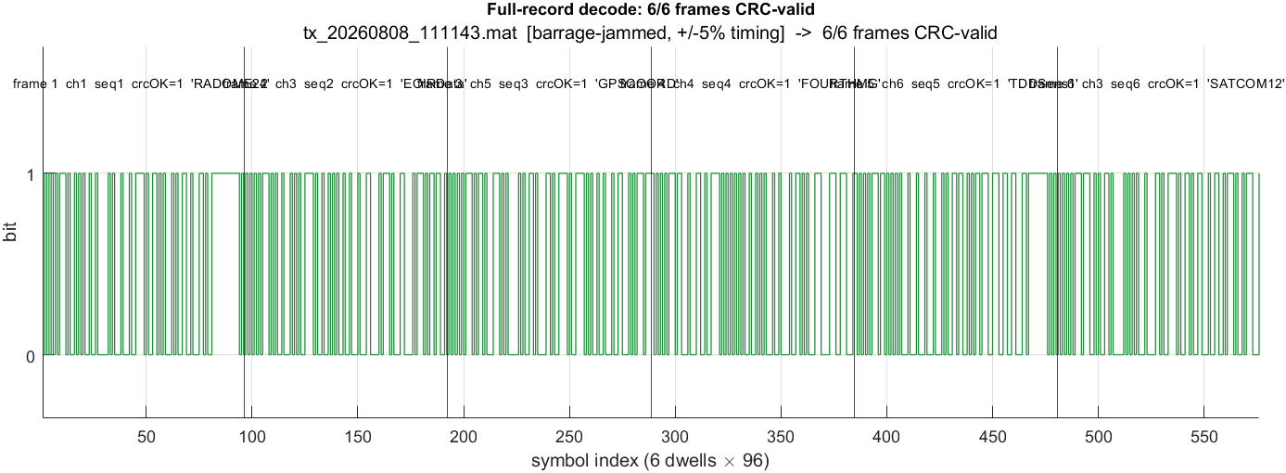
Figure 10 — Full-record decode: all six frames CRC-valid.

3. Fixed-point core and HDL implementation
The algorithm is ported to a synthesizable fixed-point core and then to Verilog through HDL Coder. Three synthesis-relevant forms exist:
Model | Role | Interface | Status
rxHardenedCore.m | Full-rate fixed-point codegen core | int16 buffer / dwell | 66/66 (MEX-verified)
rxHardenedCoreBB.m | Baseband fixed-point core (parallel) | int16 I/Q buffer | 66/66 (MEX-verified)
rxHardenedCoreBBStream.m | Streaming synthesizable DUT (full) | scalar stream + decodeNow | checkhdl clean; ModelSim pass
rxHardenedCoreBBStreamL.m | Lean streaming DUT (BUFLEN=2048) | scalar stream + decodeNow | Live ModelSim: bit-exact
The full-rate monolith cannot be scheduled by HDL Coder (its ~110k-sample buffer hangs code generation). The solution is the DDC path: decimating to complex baseband first yields ~1577 samples per dwell, so the streaming DUT buffers into a 2048-deep on-chip RAM and passes HDL conformance with only benign warnings (the I/Q buffers map to flip-flops rather than BRAM). HDL is generated with gen_bb_hdl_L.m.
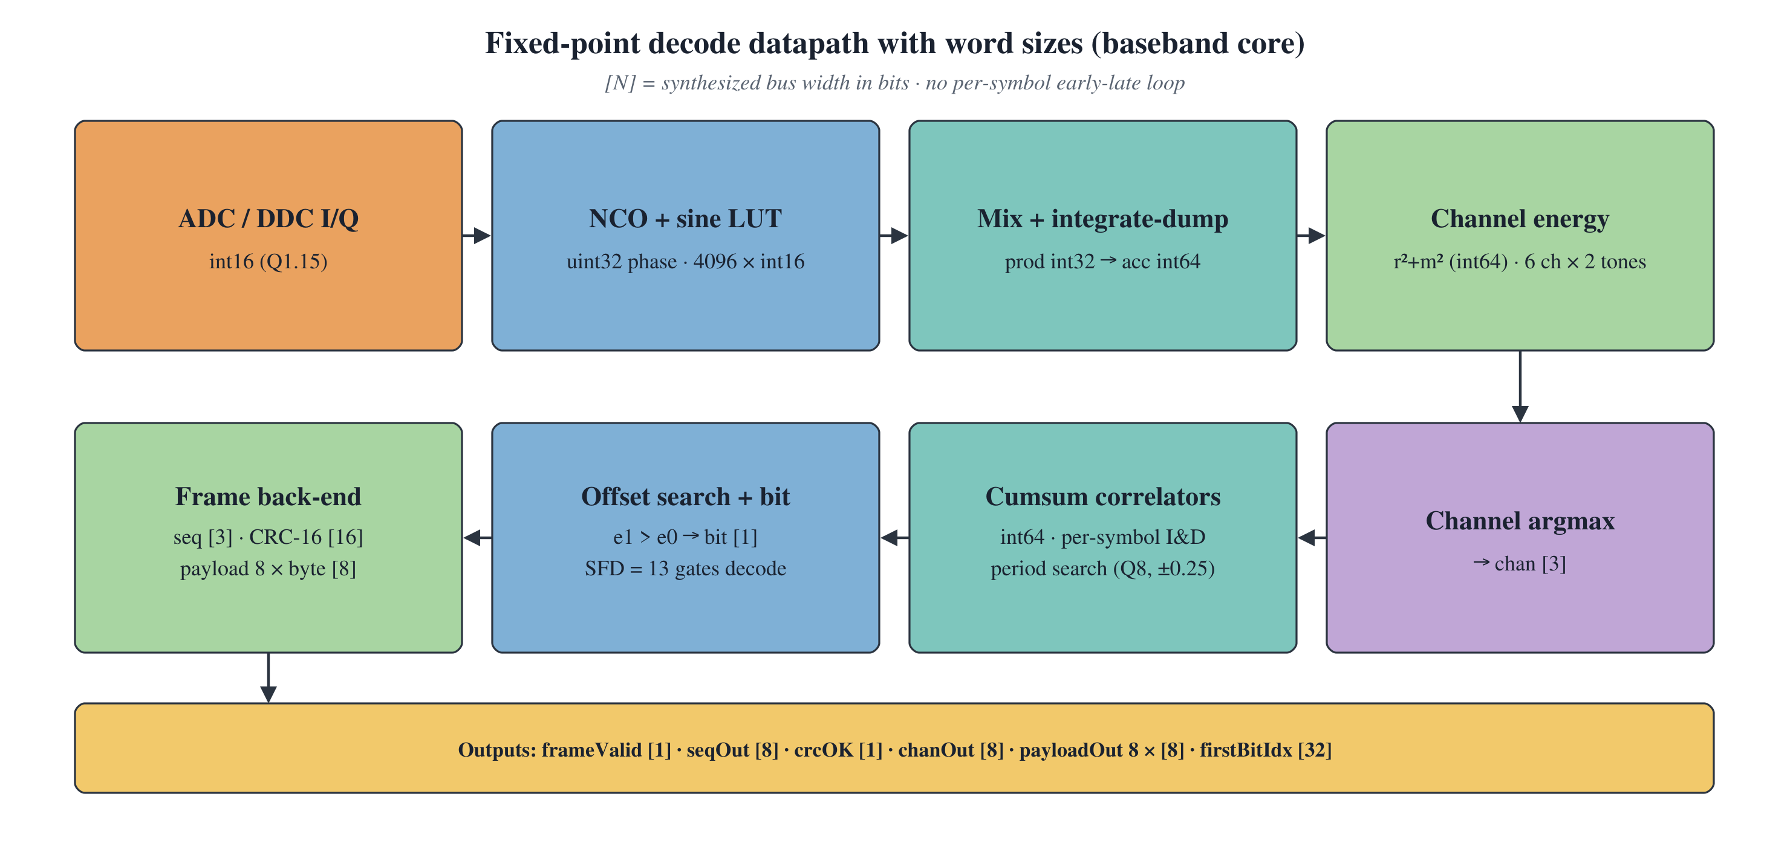
Figure 11 — Fixed-point decode datapath with word sizes: int16 I/Q → NCO/mix/integrate (int32→int64) → channel energy (int64) → argmax → cumsum correlators + offset search → bit decision → frame back-end (CRC-16, payload).

4. Results
Every waveform decodes all six frames with a valid CRC through the full receiver chain (RF front end + DDC + decode kernel). The 8 jammed files show the ±5 % period spread (measured period ranges roughly 975–1073 samples about the ~1024 nominal at the model rate) yet still reach 6/6.
Waveform | Jammed | Frames CRC-valid | Total latency (ns)
rf_waveform.mat | no | 6 / 6 | 137.6
tx_20260730_150936.mat | no | 6 / 6 | 139.6
tx_20260730_151052.mat | no | 6 / 6 | 141.6
tx_20260808_110530.mat | yes | 6 / 6 | 137.6
tx_20260808_110557.mat | yes | 6 / 6 | 143.5
tx_20260808_110631.mat | yes | 6 / 6 | 137.6
tx_20260808_110941.mat | yes | 6 / 6 | 139.6
tx_20260808_111034.mat | yes | 6 / 6 | 139.6
tx_20260808_111055.mat | yes | 6 / 6 | 141.6
tx_20260808_111119.mat | yes | 6 / 6 | 143.5
tx_20260808_111143.mat | yes | 6 / 6 | 137.6
Totals: 66 / 66 frames CRC-valid; worst-case propagation 143.5 ns against the 400 ns budget (fixed front-end latency 57.57 ns — measured analog cascade group delay + ADC + link — plus first-bit latency). Source data: results/hardened_results.csv and results/hardened_diag_summary.csv.
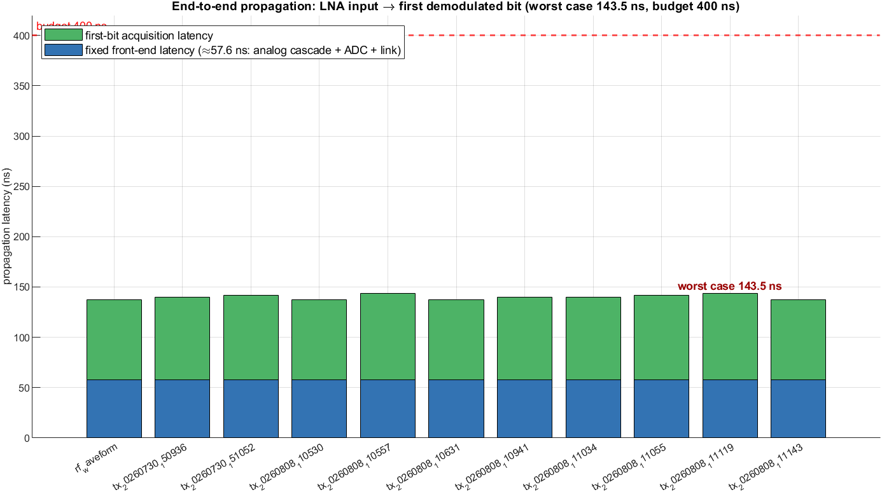
Figure 12 — End-to-end propagation budget: LNA input to first demodulated bit, well inside the 400 ns budget.

5. ModelSim verification — live session
The lean streaming DUT (rxHardenedCoreBBStreamL) was simulated live in ModelSim-Intel FPGA Starter Edition 2020.1 on one barrage-jammed dwell of tx_20260808_111143. The HDL-Coder self-checking testbench streams the dwell’s I/Q samples, raises decodeNow, and compares every DUT output against the MATLAB reference sample-by-sample.
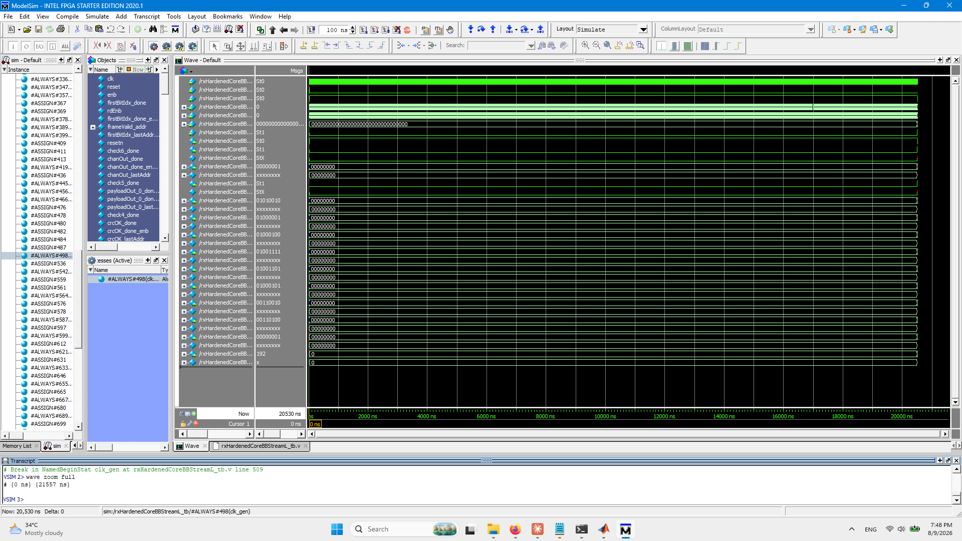
Figure 13 — Live ModelSim session. Wave window (0–21557 ns): frameValid and crcOK assert high; payloadOut bytes resolve to 0x52 0x41 0x44 0x4F 0x4D 0x45 0x32 0x34 = "RADOME24". Transcript: run completed to $stop at 20530 ns.
Result: TEST COMPLETED (PASSED) — zero mismatches. The RTL reproduces the floating-point decode bit-exact:
Output | Value
frameValid | 1
crcOK | 1
seqOut | 1
chanOut | 1
payloadOut | "RADOME24" (52 41 44 4F 4D 45 32 34)
Testbench verdict | TEST COMPLETED (PASSED) — bit-exact vs MATLAB
To reproduce this live run, see Section 7 (ModelSim commands). A batch driver (run_modelsim_all_dwells.m) runs the same DUT over every dwell of every waveform and renders a per-waveform decode figure.

6. Repository structure
The package is organised as follows. The MATLAB scripts resolve waveforms, HDL, and figures relative to the matlab/ folder, so the layout below is what the run commands assume.
HardenedReceiver/
├── matlab/ MATLAB source (addpath this folder)
│ │
│ │ -- floating-point + fixed-point receiver --
│ ├── rxHardened.m Floating-point reference receiver (66/66)
│ ├── rxHardenedBank.m Period-hypothesis bank prototype
│ ├── rxHardenedBytes.m Payload/byte helper
│ ├── rxHardenedCore.m Fixed-point %#codegen core (full-rate)
│ ├── rxHardenedCoreBB.m Fixed-point baseband core (parallel)
│ ├── rxHardenedCoreBBStream.m Streaming synthesizable DUT (full)
│ ├── rxHardenedCoreBBStreamL.m Lean streaming DUT, BUFLEN=2048 <- live ModelSim DUT
│ ├── bbDecodeBuf.m / bbDecodeBufL.m Shared decode kernel (float / lean)
│ ├── segment_dwells.m Envelope dwell segmentation
│ │
│ │ -- front end --
│ ├── rf_frontend.m RF front end: real 8-stage S-parameter cascade + AGC + 14-bit ADC
│ ├── frontend_ddc.m RFSoC digital down-converter (mix + FIR + D=64)
│ ├── sparams/ Measured Touchstone .s2p/.s3p (real front-end BOM)
│ ├── gen_frontend_fig.m Front-end cascade + spectrum figures
│ ├── gen_propagation_fig.m Propagation-budget figure
│ │
│ │ -- experiment drivers --
│ ├── run_hardened_all.m Decode all 11 waveforms (float ref, full chain)
│ ├── run_bb_core_all.m Decode all via baseband fixed-point core
│ ├── run_core_all.m Decode all via full-rate fixed-point core
│ ├── run_bank_all.m Bank-prototype harness
│ ├── run_hardened_diag_all.m Per-dwell diagnostics + figures
│ ├── run_modelsim_all_dwells.m Batch ModelSim over every dwell
│ │
│ │ -- HDL generation + ModelSim tooling --
│ ├── gen_bb_hdl.m / gen_bb_hdl_L.m HDL Coder generation (full / lean)
│ ├── export_dwell_dat.m Write one dwell's stimulus .dat into hdlsrc
│ ├── parse_vcd.m VCD parser
│ ├── render_stream_wave.m VCD -> waveform figure
│ ├── gen_modelsim_fig.m Decode-result figure
│ ├── *_tb.m MATLAB testbenches
│ ├── *_mex.mexw64 Compiled MEX (fast verification)
│ │
│ └── codegen/
│ ├── rxHardenedCoreBBStreamL/hdlsrc/ Lean Verilog + tb + .do <- LIVE DUT
│ │ rxHardenedCoreBBStreamL.v, *_tb.v, *_compile.do,
│ │ *_tb_sim.do, run_live.do, sim_capture_L.do,
│ │ sampI/sampQ/dwLen/decodeNow.dat (staged stimulus),
│ │ *_expected.dat (reference outputs)
│ └── rxHardenedCoreBBStream/hdlsrc/ Full streaming Verilog + tb
│
├── waveforms/ (11 x .mat) 3 clean + 8 barrage-jammed / +-5% timing
│
├── report/
│ ├── FH_CPFSK_Hardened_Receiver_Report.docx (this document)
│ ├── build_hardened_report.py rebuild script
│ ├── _tree_report.txt tree embedded above
│ └── images/ (30 figures)
│
├── results/ Pre-computed decode results
│ ├── hardened_results.csv Per-waveform CRC pass + latency
│ ├── hardened_results.mat
│ ├── hardened_diag_summary.csv Per-waveform jammed flag, period spread
│ └── hardened_diag/ (11 .mat) Per-waveform diagnostic time series
│
└── README.md Quick-start + command reference

7. How to run the experiments
All paths are relative to the package root. MATLAB commands assume the current folder is HardenedReceiver/matlab.

7.1 MATLAB — decode verification
% From HardenedReceiver/matlab :
addpath(pwd)
% Floating-point reference receiver, all 11 waveforms -> 66/66
run_hardened_all(true)
% Synthesizable fixed-point core (baseband DDC path) -> 66/66
run_bb_core_all(true)
% Full-rate fixed-point core -> 66/66
run_core_all(true)
% Per-dwell diagnostics + figures into ../report/images
run_hardened_diag_all

7.2 MATLAB / HDL Coder — regenerate the Verilog
Run in an isolated MATLAB (batch) process — HDL generation must not share the MCP/interactive session.
matlab -batch gen_bb_hdl_L % lean DUT -> codegen/rxHardenedCoreBBStreamL/hdlsrc
matlab -batch gen_bb_hdl % full DUT -> codegen/rxHardenedCoreBBStream/hdlsrc

7.3 ModelSim — live GUI run (the session in Figure 13)
set PATH=C:\intelFPGA\20.1\modelsim_ase\win32aloem;%PATH%
cd HardenedReceiver\matlab\codegen\rxHardenedCoreBBStreamL\hdlsrc
vsim -gui -do run_live.do

7.4 Rebuilding the MEX files (optional)
The compiled MEX files (*_mex.mexw64) only speed up the fixed-point cores — each has a plain .m source that produces the identical result, so the repo runs without them. Call the decode scripts with the flag false (the default): run_hardened_all, run_bb_core_all, run_core_all. The .mexw64 files are Windows-x64 only. To regenerate them you need MATLAB Coder and a configured C compiler (run mex -setup once). From HardenedReceiver/matlab:
codegen rxHardenedCore -args {zeros(110592,1,'int16'), uint32(0)}
codegen rxHardenedCoreBB -args {zeros(4096,1,'int16'), zeros(4096,1,'int16'), uint32(0)}
codegen bbDecodeBufL -args {zeros(2048,1,'int16'), zeros(2048,1,'int16'), uint32(0)}
Each command writes <name>_mex.mexw64 into matlab/. bbDecodeBufL_mex is only used by export_dwell_dat when re-staging a different ModelSim dwell.

8. Conclusion
The receiver chain meets its specification: reliable decode of the FH-CPFSK waveform under a barrage jammer and ±5 % timing variation, all 66 frames CRC-valid, within the 400 ns latency budget. Envelope segmentation for the period, whole-dwell channel lock, and a CRC-arbitrated offset search are ported to a fixed-point, HDL-Coder-synthesizable core whose generated Verilog passes ModelSim bit-exact against the reference, as shown in the live session in Figure 13.

